**Docker File:**

It is a text file which contains set of instructions to build the docker images.

**Instructions in Docker file:**

* **FROM :**

It will provide the Base image which consists of dependencies,Software packages and O.S to run the application.

* **RUN:**

It will used to run the linux commands.These commands are executed during the building of image.

* **WORKDIR**:

It will used to set the working directory for containers.

* **CMD:**

It will execute commands when the container is created**.**

* **ENTRYPOINT:**

It will execute the commands when container is created but it will overwritten the instruction**.**

* **COPY:**

It will copy the files from local to inside of a container.

* **ADD:**

It will copy or download the files from the internet to the container.

* **EXPOSE:**

We can expose the container port number where container listen the port number.

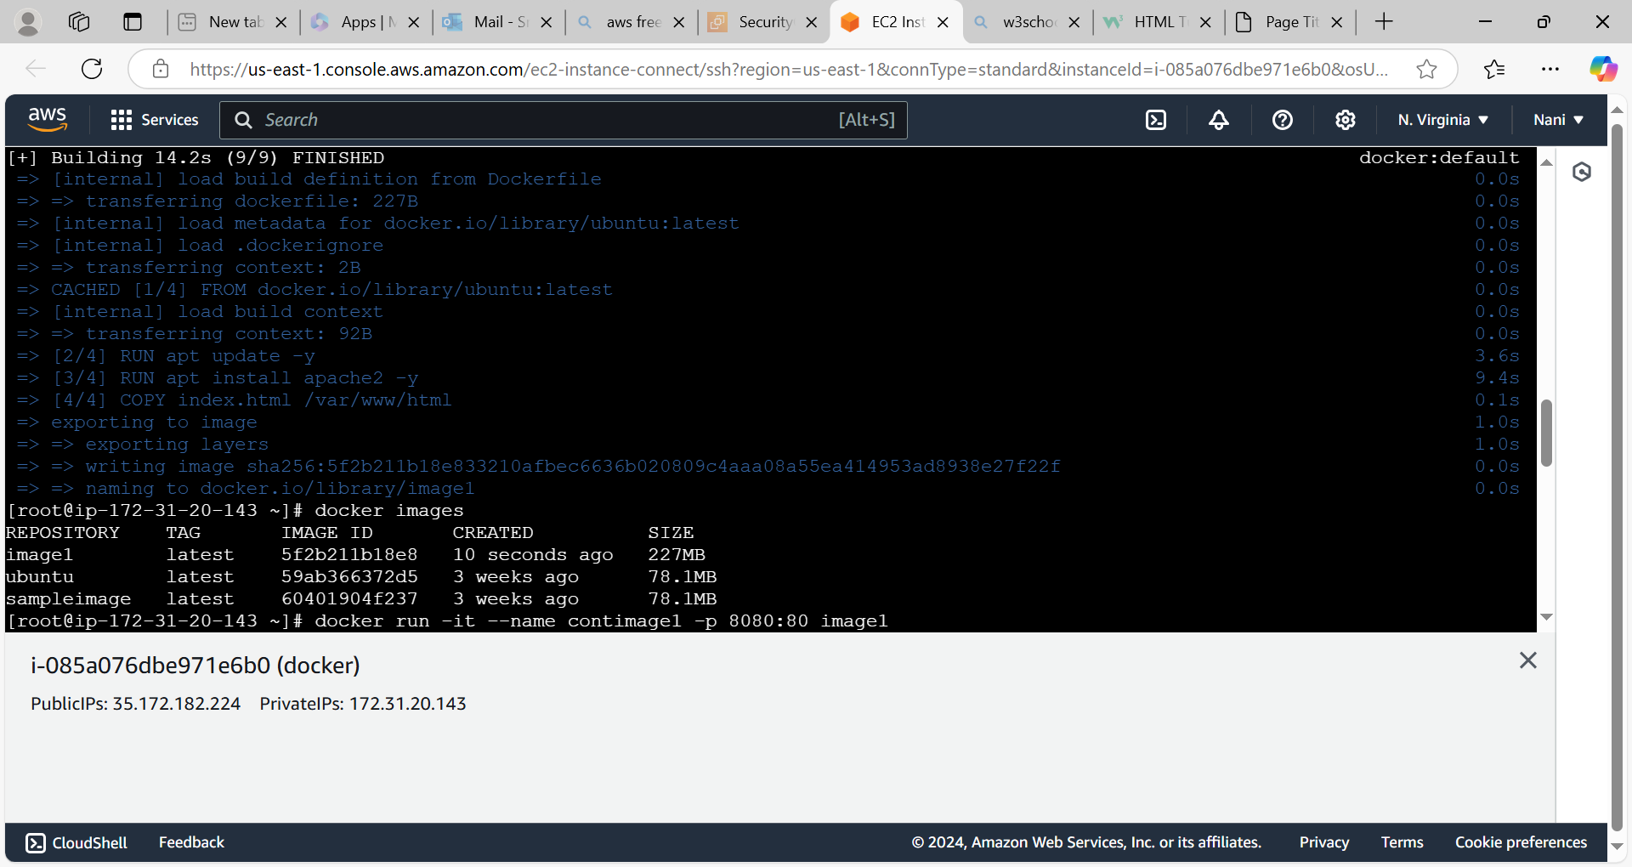

Docker file

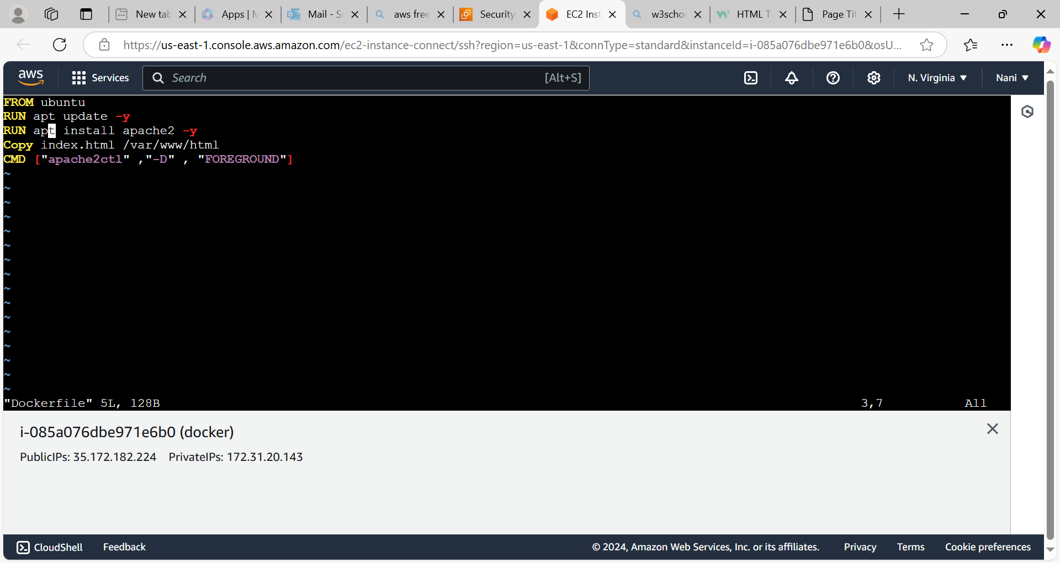

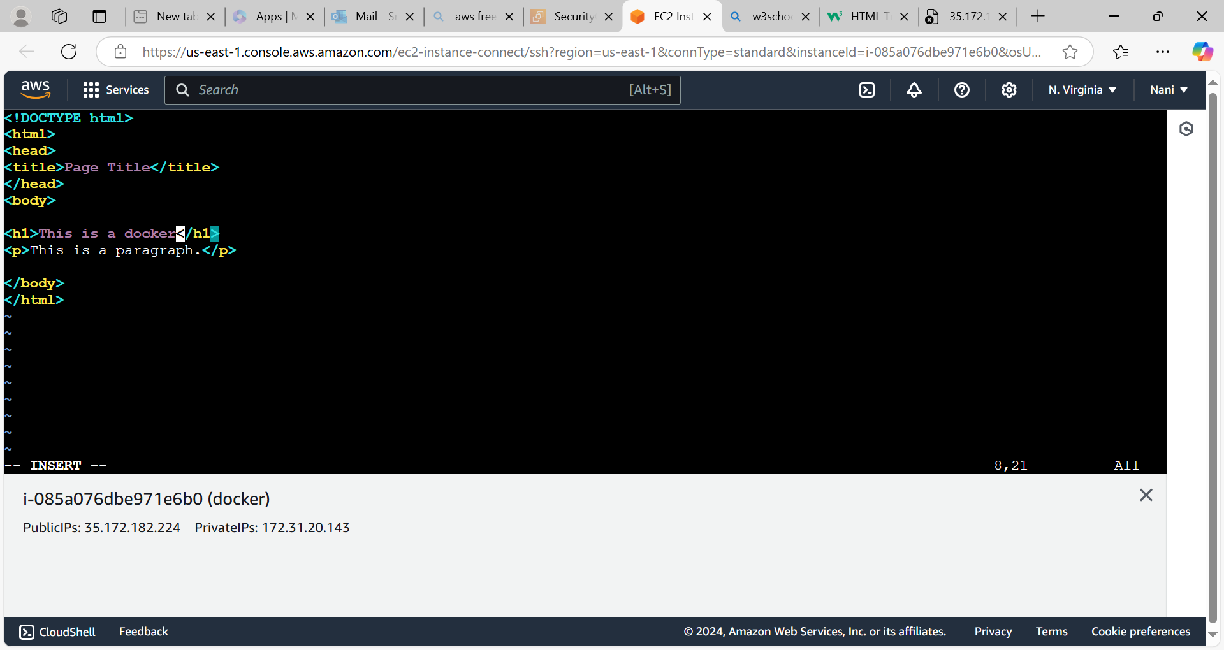

Access the application

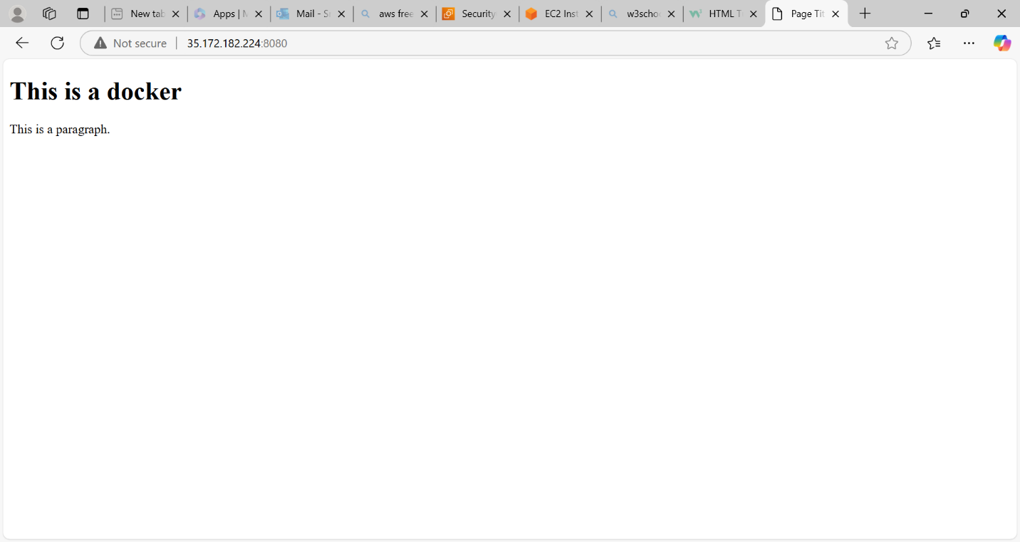

We need to go to the inside of a container to start the apache2 like below.

